**Project Design Phase-II**

**Data Flow Diagram & User Stories**

|  |  |
| --- | --- |
| Date | 27 June 2025 |
| Team ID | LTVIP2025TMID59793 |
| Project Name | Smart Sorting: Transfer Learning for Identifying Rotten Fruits and Vegetables |
| Maximum Marks | 4 Marks |

**Data Flow Diagrams:**

A Data Flow Diagram (DFD) is a traditional visual representation of the information flows within a system. A neat and clear DFD can depict the right amount of the system requirement graphically. It shows how data enters and leaves the system, what changes the information, and where data is stored.

**Flow Diagram:**

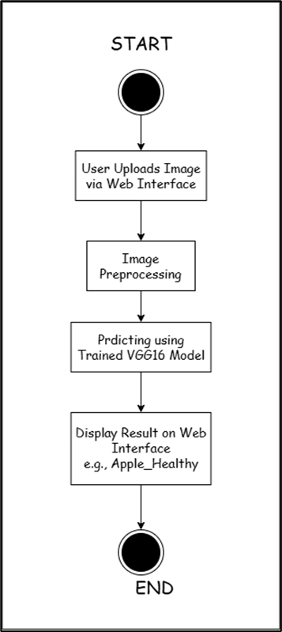

**User Stories**

Use the below template to list all the user stories for the product.

| **User Type** | **Functional Requirement (Epic)** | **User Story Number** | **User Story / Task** | **Acceptance criteria** | **Priority** | **Release** |
| --- | --- | --- | --- | --- | --- | --- |
| Food Processing Plant Head | Image-Based Freshness Detection | USN-1 | As a plant head, I want to upload images of products to detect freshness. | System accepts image uploads, correctly predicts freshness (Healthy/Rotten) with at least 90% accuracy. | High | Sprint-1 |
|  | Real-Time Sorting Assistance | USN-2 | As a plant head, I want instant freshness feedback so that sorting staff can separate unhealthy items quickly. | System displays clear, quick results after image upload without requiring technical expertise. | Medium | Sprint-1 |
| Supermarket Manager | Quality Verification | USN-3 | As a supermarket manager, I want to verify the freshness of incoming stock to reduce customer complaints. | System allows image upload of stock items, predicts freshness, and generates confidence levels above 90%. | High | Sprint-2 |
|  | Mobile Compatibility | USN-4 | As a supermarket manager, I want to use the system on my mobile device so that I can inspect stock directly. | Web interface is fully responsive and accessible on mobile devices without functional limitations. | Low | Sprint-3 |